What to do when apt-get is broken?

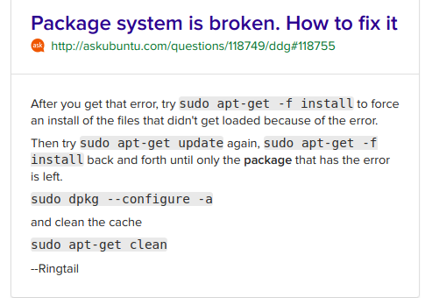

But what if the sudo apt get -f install doesent work? What you gona do?

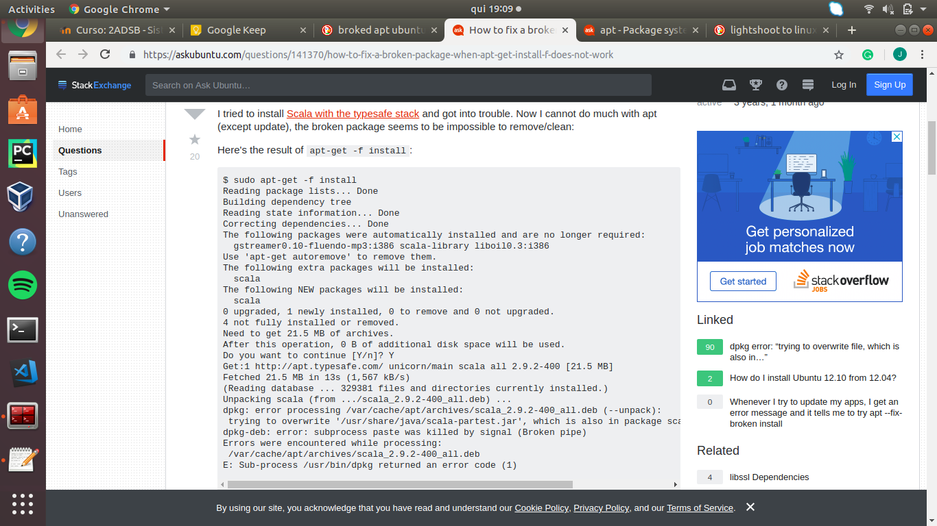

Keep in mind that:

apt-get is a popular Package Manager frontend for (mainly) Debian based flavors of Linux OS, like Ubuntu.
When you run the mentioned command, apt-get installs the package called <package> as well as any other packages (called dependencies) which would be required for the main package to function. The actual packages are pulled in from repositories which may be looked upon as a collection of packages with an informative index file detailing which packages they include.
To provide further details, these are the steps which apt-get performs when you run the mentioned command:
- Dependency resolution: apt-get learns (from the database of packages it maintains) which dependency packages needs to be installed as well and creates a recursive tree list of all the required packages (with other details like compatible versions, package file name, repository info, etc.).
- Compute which Packages needs to be downloaded: Then the system checks which packages are already installed in the system, and which package files (correct version), if any, have already been downloaded to a cache.
- Download Package Files: The actual download link is computed using the repository info and the package file name. apt-get then downloads the required files successively and stores them in a cache directory. It is interesting to note that apt-get download phase is generally interruptible and resumable.
- Install the Package Files: Finally, apt-get calls upon dpkg (which is technically the actual package manager program under the hoods for Debian) to install each of the cached package files in succession.
P.S.>
The apt-get install command is usually to be prepended by sudo, which essentially means that you need to run the command with elevated privileges as root orsuperuser. This is a security requirement, as apt-get install affects the system files (beyond your personal home directory) while installing packages.
Source: https://www.quora.com/How-exactly-does-the-sudo-apt-get-install-package-work-in-Linux?fbclid=IwAR1GAP2wgB9qAi2ZYWorgCmPINng4ZGETy4QufQp1eGwD7LCc70Qzr7uM_M

